Process Name: | Transferring a Student (Within Your School District)
Last Updated: | 04/25/2017 12:04 PM
Initial Author: | Mary-Jo MacRae (EECD)
Last Updated by: | Cynthia Gilks MacInnis (ASD-N)
Time period(s) most often used: | September-June

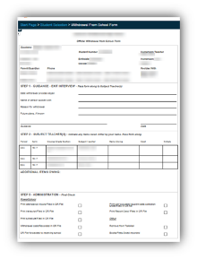
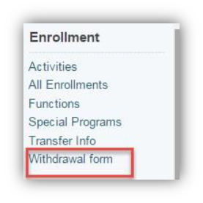
Transferring a Student (Within Your School District)
Prior to starting the transfer process please make sure the Withdrawal Form has been printed and completed. To retrieve the withdrawal form select student on start page. Enrollment>Withdrawal Form

Use the NB Report Period Attendance by Class and run it for the individual student who is transferring for the date range the student attended your school. This report can be printed and should be added to the Cumulative Record. A job aid for creating this report is found in Data Connect.

Before starting the final withdrawal process (as described under the title “Sending School”) please attend to the following detail as it relates to your student’s grade level:
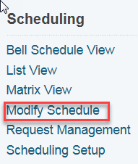
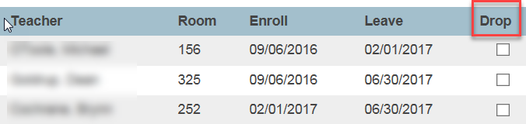
- K to 8 – make sure that courses are dropped using Modify Schedule. Start Page>Student Name>Modify Schedule

- 9 to 12 – Two steps. The second step has 2 parts:

Step 1: Courses are dropped using Modify Schedule Start Page>Student Name>Modify Schedule

Step Two (2 parts) Part 1: Open term in the upper right hand corner of the start page. Select the upcoming year. In the example the upcoming year (i.e. next school year) is 17-18.
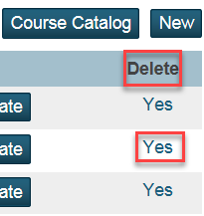
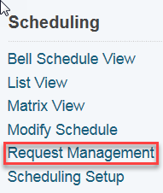
Part 2: Clear the future requests for the upcoming year. In upcoming year: Start Page>Student Name>Request Management> Modify Schedule-Requests. Reminder: return to the current school term after this is finished and in order to proceed with the transfer.

Sending School: Please ensure the steps up to this point have been completed prior to proceeding with the actual transfer OUT and transfer TO

AAs in K-Gr 8 Schools: Provide teacher with Excel spreadsheet found on Data Connect titled: Transfer template K-8 by grade level and program of study. Teachers are asked to complete this and for the information to be included in the Cumulative Record upon transfer.

The Parent/Guardian notifies the school that student will be transferring to another school. The AA then completes a Transfer OUT and a Transfer TO as follows:

Transfer OUT
Start Page>Search for student
Enrollment>Functions>Transfer Out
[Leave blank] “Check here if student intends to enroll in school during next school year.”
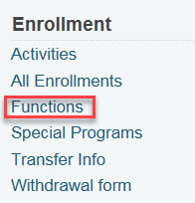
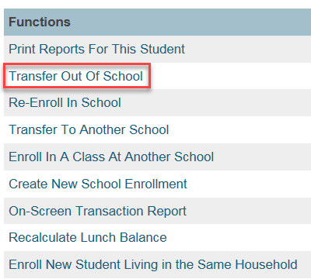
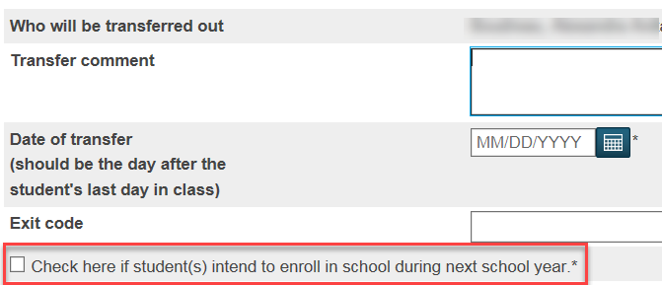
Transfer TO
- Receiving school contacts former school requesting cumulative record & electronic transfer within PowerSchool
- Complete Transfer TO procedure

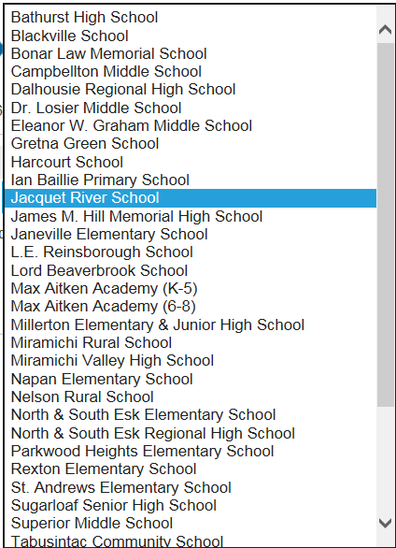
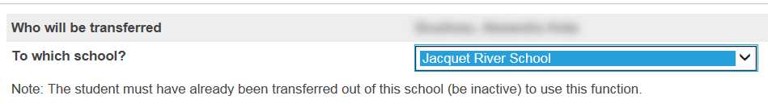
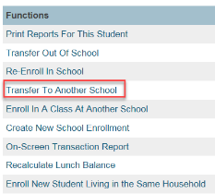
Enrollment>Functions>Transfer TO
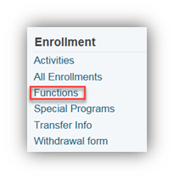
Note: Student becomes an Inactive student at receiving school until re-enroll procedure is completed.
Send cumulative record to receiving school.

Receiving School

Re-Enroll
Start Page>Search for both Active and Inactive students
Enrollment>Functions>Re-Enroll In School
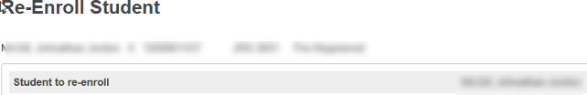
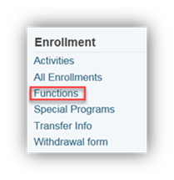
[No] “Restore Class Enrollments”
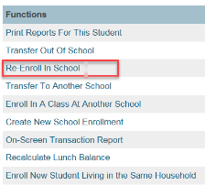

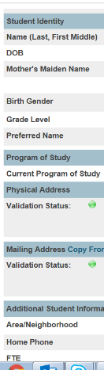
General Demographics
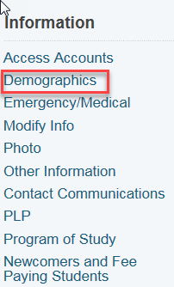
- Student Identity
- Physical Address
- Mailing Address
- Additional Student
- Custody Information
- Student Contacts

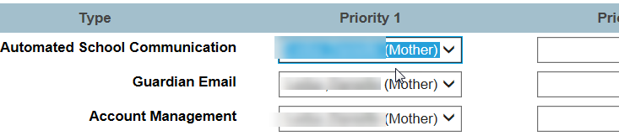
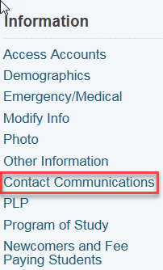
Contact Communications
Priority 1 = Mother
Priority 2 = Father
Priority 3 = Guardian?

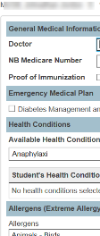
Emergency/Medical
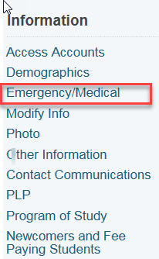
- General Medical Information
- Emergency Medical Plan
- Health Conditions
- Allergens

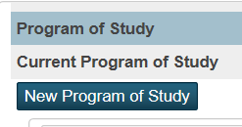
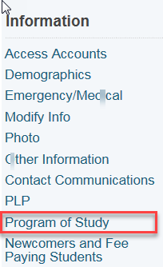
Program of Study
New Program of Study

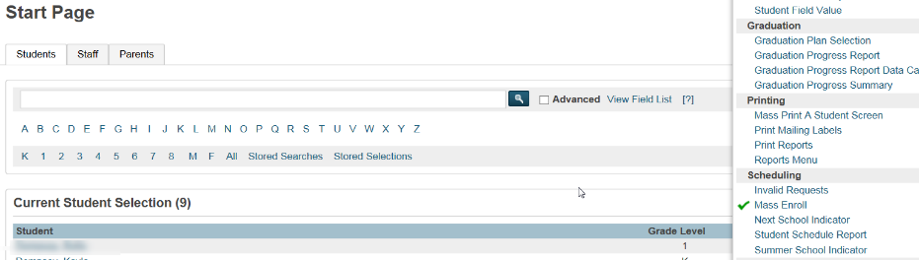
Scheduling Setup
- Next Year Grade
- Schedule This Student
- Next School Indicator
- Mass Enroll

Helpful Searches
Start Page>

Student Name “Searches for the specific student who is active”
/student name “Searches for specific student who is inactive”

